 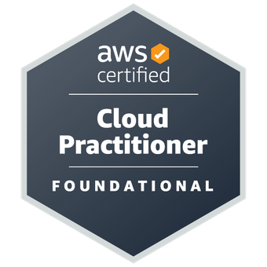

|  |
| --- |
| **Name** **: Chinnala Uday Kumar**  **Role** **:** **Trainee Engineer** |
| **Professional Background** |
| As a Trainee engineer I had around 9 months of experience in AWS services. I got certified as an AWS cloud practitioner. I have been trained in AWS and have a basic understanding of Linux commands, git and MySQL. |
| **Key Technologies** |
| **AWS Cloud computing:** Having Good Knowledge of compute, storage, networking and database services. Ability to identify which service needs to be used for the requirement. -Services like- EC2, S3, Route 53, EBS, EFS, VPC, cloud watch, SNS, IAM, SQS, Security groups, Load Balancer.  Having Knowledge in Linux, SQL. Basics of Linux, MySQL.  **DevOps Tools:** I have basic knowledge in Git & GitHub, Jenkins, Maven. |

|  |
| --- |
| **Roles & Responsibilities** |
| * Having Basic knowledge of Linux Commands. * Having Basic Knowledge in SQL commands. * Launched EC2 Instances in public and private and connected through EC2 terminal or Putty or Git bash, installing multiple software’s, like JAVA, Jenkins, Tomcat, Nginx, and Docker. * Simple Storage Service: Creating Buckets, uploading files and creating Bucket Policies for Public Access and Private Access, Cross-Region-Replication using different Regions and Accounts. * Created AMI’s volumes, snapshots and attached AMI’S to the existing Instances. * Created Load Balancer, through load balancer attaching target groups and routes request to the registered targets. * Cloud Watch: Created Cloud Watch Alarms for billing & usage notification purposes. * SNS: Created SNS and integrated with S3. * Elastic File System: Created EFS and attached EFS into those multiple EC2 Instances. * IAM: Created IAM Users, Groups, Roles, attaching Roles to users and attaching polices to the users we created. Monitoring Users through a user by giving permissions. * AWS Shared Responsibility Model, AWS supporting Plans & Billing Concepts, Cost Optimization. * Machine Learning: Having practical knowledge on Amazon Polly & Amazon Transcribe. * Networking and Content Delivery: VPC: Knowledge on VPC components, Subnets, IGW, NGW, EIP & Route Tables.   **DevOps**:   * Using Jenkins, deploying a war file into a tomcat using public & private repository. * Created multi-branch pipeline and executed the code step by step CI-CD Process. * Using Jenkins deployed the code and executed the code through Dev to Test and Test to Production environment. |
| **Certification**   * AWS Certified Cloud Practitioner [[ELJQ0KY2TN141RSX](https://www.credly.com/badges/24fb8bcc-c2fb-4fb1-b807-c68b08c57b8e)] |